

☎ : 905-487-3428 🌐 : www.acmetex.com Warehouse Location: Toronto · Edmonton
ACME-KSS3/3
Para-Aramid with 316 stainless steel wire sewing thread
Description:
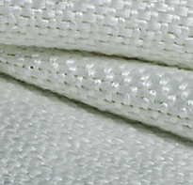
KSS3/3 Para-Aramid(Kevlar by Dupont) is made with 100% Polytetrafluoroethylene (PTFE), making it extremely lubricant and durable which allows it to for better hook pickup, lower elongation and strength for few knots and breaks. It also provides a 316 stainless steel sewing thread offer the strong tensile strength while the 316 with high Inconel stainless steel wire provides excellent chemical resistance.

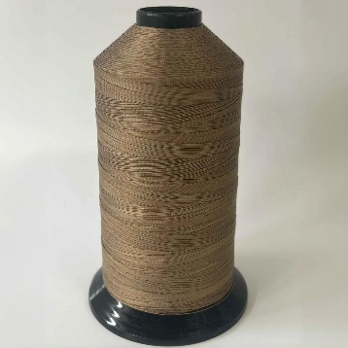
Advantages:  - Heat resistant  - Chemical resistant  - Good sewability  - Flexibility  - Good tensile strength | Applications:  - Welding blanket/curtains  - Expansion joints  - High temperature insulation  - Heat shield/containment  - Gaskets & over-door seals  - Removable insulation cover  - Filter bag


Property Data
KSS3/3

Material | Para-Aramid with 316 stainless steel wire
Twist | 3 ply with 3 wire
Tensile strength(lbs) | Approx. 27
Final Twist | “Z”
Para-Aramid Decomposition Point | Approx. 878°F (470°C)
Stainless Steel Melting Point | Approx. 2552°F (1400°C)
Size of the thread | 0.011”
Weight per spool | About 1.1 lbs(500 grams)

